# Department of Computing

**CS220: Database Systems**

**Lab 04: Introduction to SQL**

**Time: 0900-1200**

# Instructor: Dr. Shams

**Lab Engineer: Miss Sadia Amir**

# Lab Task

## Using Sakila Database

Formulate SQL queries for the following needs and execute them on Sakila database.

1. **Retrieve first and last name of actors who played in AFRICAN EGG.**

## QUERY

Select first_name,last_name from actor,film,film_actor

where film.title="AFRICAN EGG"

AND film_actor.film_id=film.film_id

AND film_actor.actor_id =actor.actor_id;

## OUTPUT

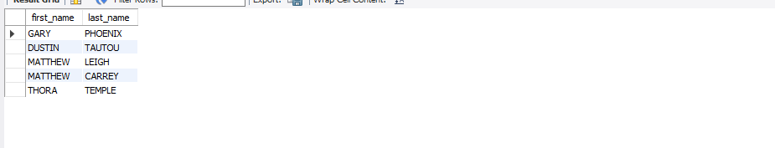

1. **Retrieve actor id and their names with their addresses.**
2. **Retrieve names of movies starting with A.**

## QUERY

Select title from film where title LIKE "A%"

## OUTPUT

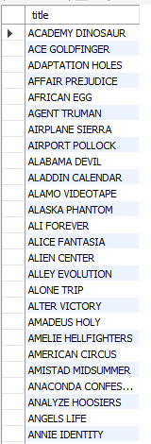

1. **Retrieve data of all actors whose names are not starting with Z.**

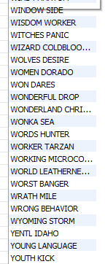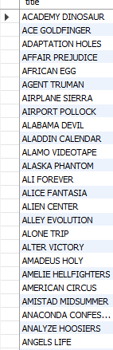

1. **Retrieve rental and return date for the movie ALASKA PHANTOM.**

## QUERY

SELECT return_date,rental_date from film,rental,inventory

where film.title = "ALASKA PHANTOM"

AND film.film_id=inventory.film_id

AND inventory.inventory_id=rental.inventory_id;

## OUTPUT

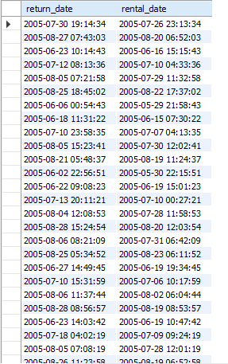

1. **Find and display the Income (payments) generated during August 2005. Sort them in the descending order**.

## QUERY

SELECT amount,payment_date from payment where payment_date BETWEEN "2005-05-01" AND "2005-08-31" ORDER BY amount DESC;

## OUTPUT

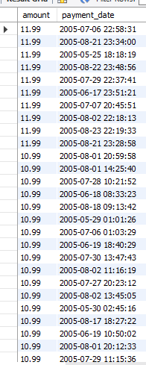

1. **Find and display the Email addresses of customers who haven’t paid even a single penny yet.**

## QUERY

Select email from customer,payment where payment.customer_id=customer.customer_id && payment.amount**='0';**

## OUTPUT

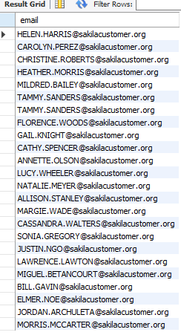

**8.Extract information of actors whose names ends with character ‘T’**

## QUERY

Select * from actor where last_name LIKE "%T"

